Day in the Life of the Hudson River 10/13/22
Inwood Marina, Manhattan, NY
RIVER MILE: 12.75
Salt Front: ~ RM 76
NYC Parks Dept – Rob Mastrianni, Grant Wheeler, Max Soo, Marc Sanchez, Bonnie McGuire
Comprehensive Model School Project– Caroline Castro
70 students & 10 adults
Latitude 40.8°N & Longitude –73.9°W
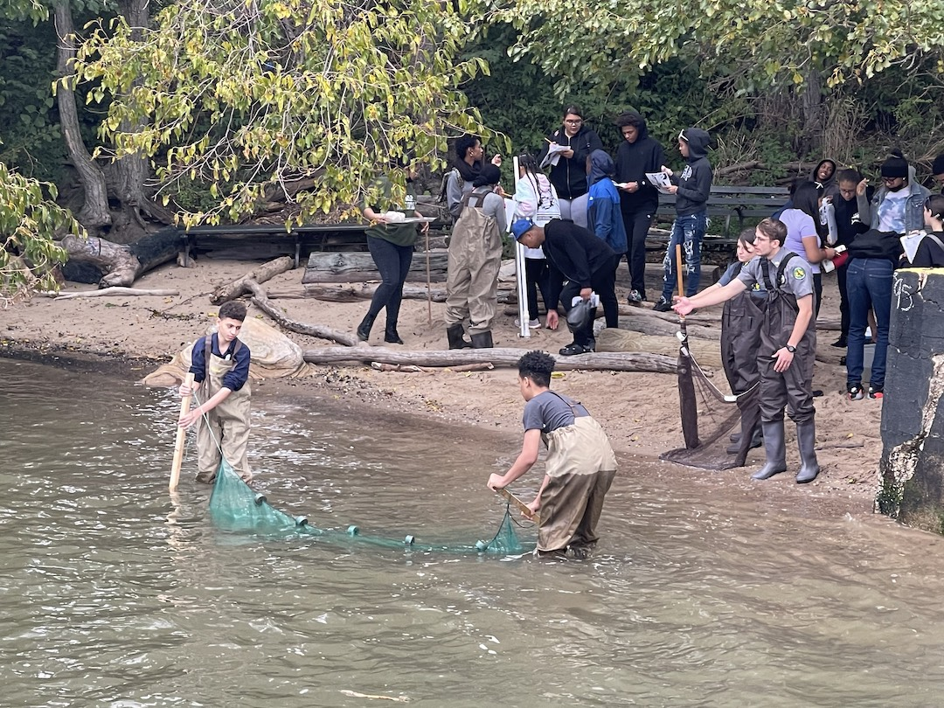 | 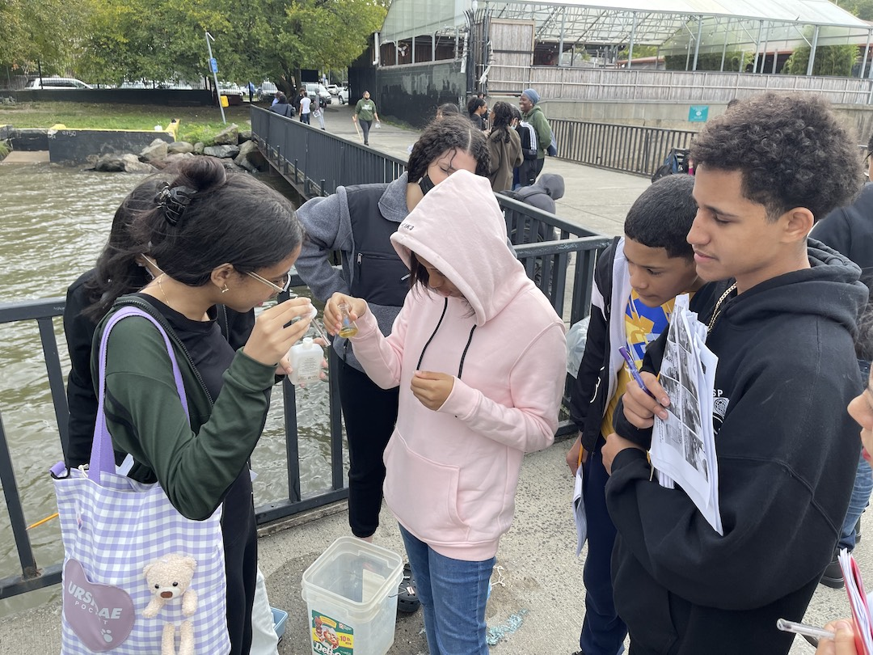 | 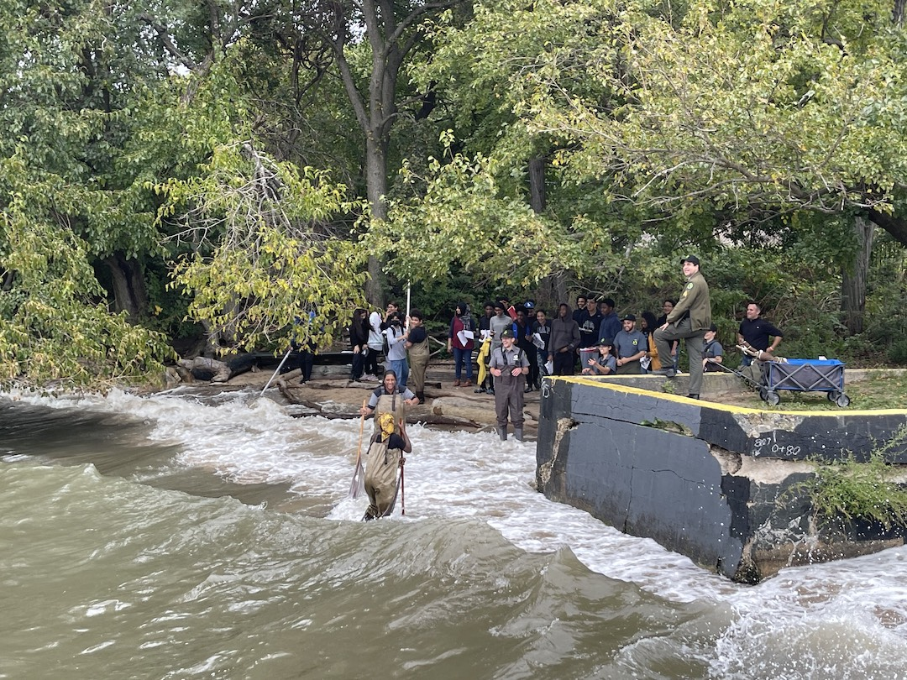

Location: Inwood Marina, NY
Area: Urban, small beach
Surrounding Land Use: 100% Urban/Residential
Sampling Site: Pier, beach, parking lot
Shoreline: 100% Muddy
Water: Choppy
Plants in area: No plants in the water
River Bottom: Muddy
*NR = Not read/recorded
ITEM |  | Time |  | Reading |  |  |  | Comments
Physical
Air Temperature- |  | 10:30 AM |  |  |  |  | 64°F
Wind Speed: |  | 10:30 AM |  | Anemometer  NR |  |  | Beaufort  3 | Direction  NR
Weather today |  | 11:30 AM |  | > 75% cloud cover |  |  | Drizzle
Weather the past 3 days: |  | Warm, sunny
Tides- NR, lost tide stick |  | Time |  | Rising, Falling, Unchanged |  |  | Water Height (cm)
Current- |  | Time |  | Cm/sec |  | Knots | North/South | Ebb/Flood/Still
 |  | 10:41 AM  11:18 AM |  | 41.7  3.3 |  | 0.85  0.3  0.25 |  | Slack  Flood  Flood
Water Temperature- |  | 10:56 AM |  | 19°C |  |  | 66.2°F
Turbidity- Long Sight Tube (120 cm) |  | 11:30 AM  12:10 PM |  | 19.6 cm  26 cm
Chemical
Salinity- NR
Standardized Salinity –
DO – Hach Drop Count Kit |  | Time  10:56 AM  11:16 AM |  | Temp  19°C  19°C |  |  | ppm DO  5 ppm  7 ppm | % saturation  NR  NR
pH – |  | 10:44 AM |  | 7.4
Nitrates- NR
Phosphates- NR
Alkalinity- NR
Biological
Fish – Seine & Traps |  | Number |  | Name |  |  | Length of longest | Length of smallest
10:34 –10:52 AM |  | 30  1 |  | Atlantic Silverside  Black Seabass |  |  | 11 cm
Fish Totals |  | TOTAL:31 |  | Diversity: 2
Macroinvertebrates |  | Number |  | Name |  |  | Length of longest | Length of smallest
 |  | 2  2 |  | Blue Crab  Jellyfish sp.
Macroinvertebrate Totals |  | TOTAL:4 |  | Diversity: 2
Sediment Core - NA
Length | H2S smell |  | Oxid Top |  | Oil |  | Grain Size | Other Features
Boats-
 | Time |  | Name |  | Color |  | North/Southbound | Light/Loaded
Commercial | 12:10 PM  1:22 PM |  | NR  NR |  | NR  NR |  | Southbound  Northbound | Loaded  Loaded
Recreational

